Mercy Matters: Liturgical Reflection
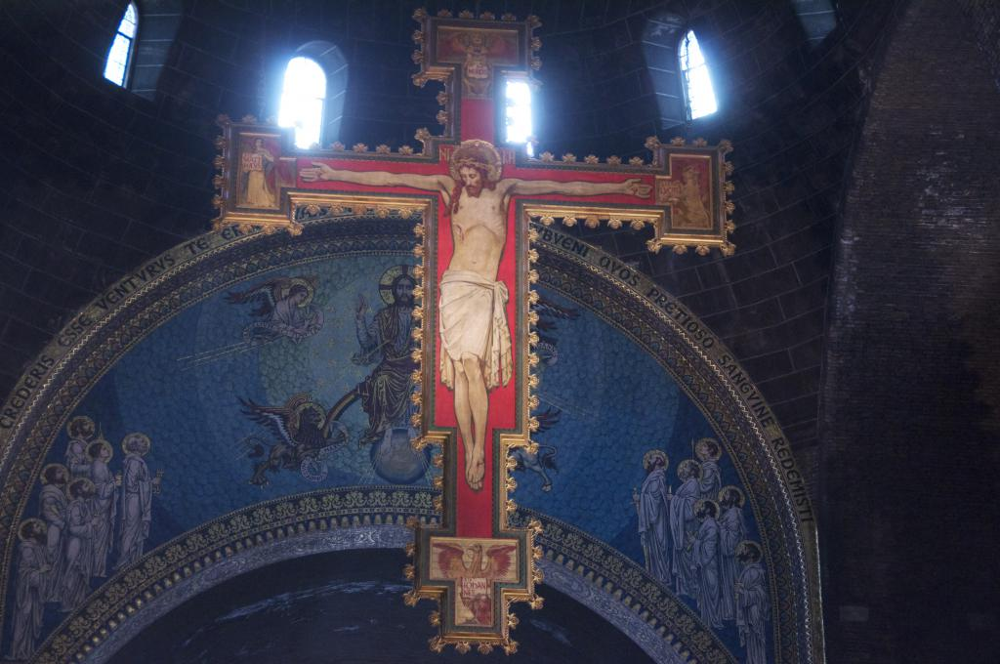
There is a saying familiar to many Catholics: It is the Mass that matters. It is an old saying, and still pertinent.
However, in a world where many people lack even a basic religious formation, the Mass is a puzzle and there is something prior that they first need to engage with. Mercy is proposed as that something: the mercy of God, the love of God in action. Mercy matters to us all, for we are often sore from our experiences of life, and mercy is a salve to our bruises and wounds, as well as a first taste of salvation.
Pope Francis has called the Church to keep a Jubilee Year of Mercy, beginning on 8 December. It is to be a year for the Church to learn afresh that mercy matters, and to learn this especially by witnessing and working so that the world might better recognise the love and mercy of God.
This matters.
It matters because in the world there is much that drains life from us, and mercy restores that life.
It matters because sometimes we are responsible for damage done to the world and to others, and alone we cannot put the world right, or them, or ourselves.
It matters because the mess is too great, and complex and intractable for us, but not for God. God’s love offers a way back to good order, and justice, through mercy, healing and reconciliation.
Mercy enables change. It meets us in our differentiation and in our separation and brings about something new and better than we presently have. Portia, in Shakespeare’s Merchant of Venice, witnesses to that:
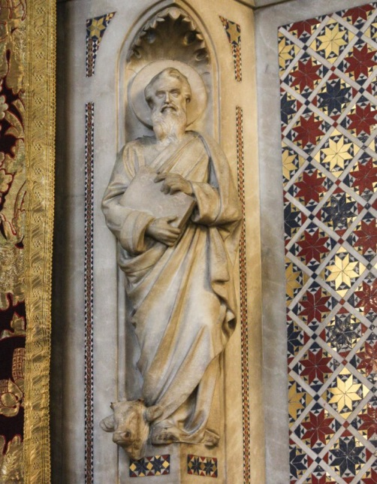
‘The quality of mercy is not strained;
It droppeth as the gentle rain from heaven
Upon the place beneath.
It is twice blest;
It blesseth him that gives and him that takes:
‘Tis mightiest in the mightiest; it becomes
The throned monarch better than his crown:
His sceptre shows the force of temporal power,
The attribute to awe and majesty,
Wherein doth sit the dread and fear of kings;
But mercy is above this sceptred sway;
It is enthronèd in the hearts of kings,
It is an attribute to God himself;
And earthly power doth then show likest God’s
When mercy seasons justice. Therefore…
Though justice be thy plea, consider this,
That, in the course of justice, none of us
Should see salvation: we do pray for mercy;
And that same prayer doth teach us all to render
The deeds of mercy.’
The Jubilee Year gives us the opportunity to know and to enjoy the truth of this more deeply than we do at present: to enjoy the truth of this more deeply than we do at present. It touches on our identity as Church, for it gives us fresh opportunity to become more effective witnesses to the grace of God. For all mercy begins with God and, when we are open especially to the sharing of the gift, all mercy leads us to God.
The Jubilee is a part of the new evangelisation, to which the Church was called by Pope St John Paul II in the millennium year, and which has been repeated by Pope Benedict XVI and now Pope Francis.
A fundamental resource is Luke’s Gospel, that is used on Sundays during this year, when the Year C cycle of Sunday readings is used, beginning on the first Sunday of Advent.
It is key for a number of reasons. Firstly it is the word of God, in, through and as which Jesus himself speaks with us, guiding us through the year and its experiences, its joys and challenges.
Secondly Luke’s Gospel is the source of so many of the scripture passages that speak to us most clearly of the mercy of God. Here we find the parable of the lost coin, the lost sheep, and the lost sons. Here we find the stories of the nativity of Jesus, most of what we know from Scripture of Mary and such tender accounts of the Resurrection. Luke writes with an evident interest in the way that the mercy of the Gospel challenges the financial underpinning of many relationships in society, back then and maybe even more so now.
We have the instructions about generous giving (Lk 6.30 and 6.38), the parables of the importunate friend (Lk 11.5ff) of the fool hoarding wealth, of providence and almsgiving (Lk 12.13ff), of the crafty steward and the right use of money (Lk 16.1ff), of the Pharisees’ love of money and the parable of the rich man and Lazarus (Lk 16.14f and Lk 16.19ff) of the Pharisee and publican (Lk 18.9ff), of the talents (Lk 19.11ff); the stories of the rich aristocrat (Lk 18.18ff) and Zacchaeus (Lk19.1ff), the teaching about paying tribute to Caesar (Lk 20.20ff) and of the widow and her mite (Lk 21.1ff).
In our society when so many decisions regarding money and wealth seem to disadvantage the poor and favour those who already have more than enough, there is surely teaching here about mercy and finance that we need to grapple with.
And it is to such a fresh grappling that the Year of Mercy, and the Advent of the Church’s new liturgical year call us. We know the stories already, we know the teaching of the Church, at least pretty much. But what is called for is a new conversion, renewal, wholeness.
The Year of Mercy and Advent call all of us who are not yet good, who are not yet holy, to a fresh encounter with Jesus Christ, God’s mercy incarnate. If we long for the world to be changed, we need to be open for wholesome change in ourselves first.
Hear again some of the phrases in the Church’s prayers for use at Mass during Advent:
‘May these mysteries, O Lord,
in which we have participated,
profit us, we pray,
for even now, as we walk amid passing things,
you teach us by them to love the things of heaven
and hold fast to what endures.
Through Christ our Lord. Amen.'
Prayer after Communion (for the first Sunday of Advent)
There is great reward for us, but is not something we can earn. It is gift, inheritance. It is ours, if it is to be ours, because of what Christ did and does.
Christ who ‘assumed at his first coming
the lowliness of human flesh,
and so fulfilled the design you formed long ago,
and opened for us the way to eternal salvation,
that, when he comes again in glory and majesty
and all is at last made manifest,
we who watch for that day
may inherit the great promise
in which now we dare to hope….’
Preface I of Advent.
God comes in flesh; mercy lives among us so that we can learn how to be fully human. We achieve that when we most fully imitate Christ, when we learn to live love. The coming months offer us a further privileged opportunity for a new and deeper relationship with Christ, our neighbour and ourselves.
Fr Allen Morris chairs the Liturgy Commission of the Dioceses of Westminster. This article first appeared in the November 2015 edition of the Westminster Record.

