Shrines & Holy Doors
During the Jubilee Year of Mercy, you are invited to make a pilgrimage to the shrines in the diocese, many of them hosting a Holy Door.
The act specified by the Holy Father for the Year of Mercy is ‘a brief pilgrimage to the Holy Door.’
In addition to Westminster Cathedral, the Cardinal has designated the following parishes at which the indulgence may been gained by passing through their Holy Door
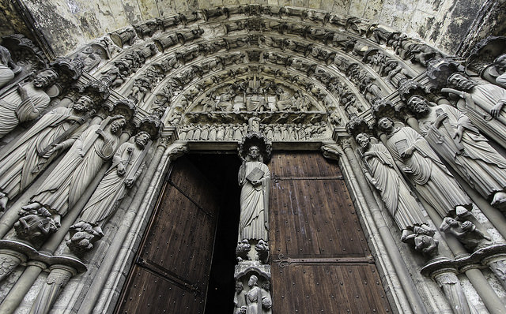
Brook Green: Holy Trinity Church,
The Italian Church: St Peter's Italian Church
Clerkenwell: Church of Saints Peter and Paul,
Enfield: Our Lady of Mount Carmel & Saint George,
Haverstock Hill: St Dominic,
Hounslow: Church of St. Michael & St. Martin
Kingsland: Church of Our Lady and St Joseph
Lincoln’s Inn Fields: Church of St Anselm and St Cæcilia

Marylebone: Our Lady of the Rosary
Soho Square: St Patrick’s
Stanmore: St William of York
Waltham Cross: Our Lady of the Immaculate Conception and St Joseph
Welwyn Garden City: Our Lady, Queen of Apostles,
Willesden: Our Lady of Willesden:

