ST MARY’S CATHOLIC PRIMARY SCHOOL

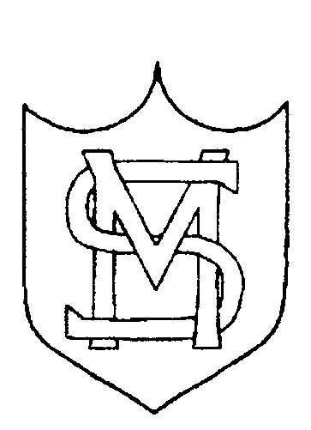

ACHIEVEMENT 2019

PHONICS (End of Year 1)

SCHOOL | LOCAL AUTHORITY | NATIONAL
86% | 81% | 82%

END OF KEY STAGE 1 (END OF YEAR 2)

PERCENTAGES ACHIEVING AT LEAST THE EXPECTED STANDARD

READING

SCHOOL | LOCAL AUTHORITY | NATIONAL
79% | 70% | 75%

WRITING

SCHOOL | LOCAL AUTHORITY | NATIONAL
79% | 65% | 69%

MATHEMATICS

SCHOOL | LOCAL AUTHORITY | NATIONAL
85% | 73% | 76%

PERCENTAGES ACHIEVING GREATER DEPTH

READING

SCHOOL | LOCAL AUTHORITY | NATIONAL
21% | 21% | 25%

WRITING

SCHOOL | LOCAL AUTHORITY | NATIONAL
21% | 12% | 15%

MATHEMATICS

SCHOOL | LOCAL AUTHORITY | NATIONAL
26% | 19% | 22%

SCIENCE

 | NUMBER OF PUPILS | SCHOOL – EXPECTED STANDARD + % | NATIONAL – EXPECTED STANDARD + %
All Pupils | 61 | 87 | 82
Male | 32 | 81 | 80
Female | 29 | 93 | 85

END OF KEY STAGE 2 2019

 | SUBJECT | % at EXPECTED STANDARD | % at HIGHER STANDARD
National 2019 | Reading | 73 | 27
School 2019 | Reading | 82 | 25
National 2019 | Mathematics | 79 | 27
School 2019 | Mathematics | 89 | 25
National 2019 | Grammar, Punctuation and Spelling | 78 | 36
School 2019 | Grammar, Punctuation and Spelling | 93 | 65
National 2019 | Writing | 78 | 20
School 2019 | Writing | 89 | 24
National 2019 | Science | 83
School 2019 | Science | 84

Progress

Subject | Progress Score | Progress Rate
Reading | -0.17 | Average
Writing | +0.79 | Average
Mathematics | +0.25 | Average
Reading, Writing and Mathematics % (combined)

 | School | Local Authority | National
% of pupils achieving the expected standard in reading, writing and mathematics | 78 | 67 | 65
% of pupils achieving the higher standard in reading, writing and mathematics | 7 | 11 | 11

Average Scaled Score

 | School | Local Authority | National
Reading | 105.34 | 104.51 | 104.41
Mathematics | 106.49 | 105.57 | 105.05
Grammar, Punctuation and Spelling | 111.5 |  | 106.3

