St.Mary’s Nursery Summer Term 2024
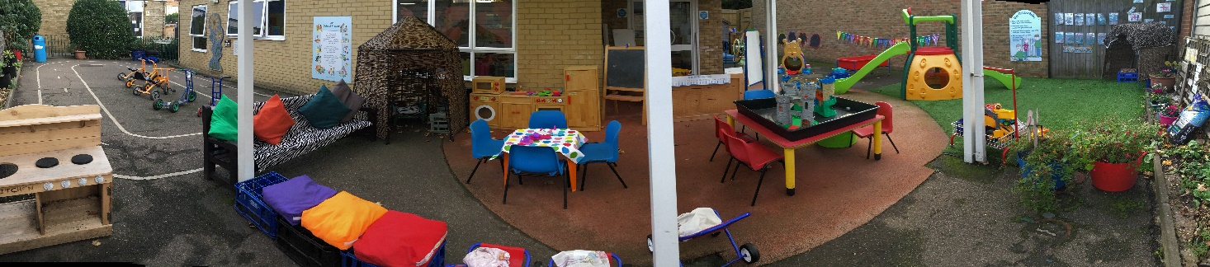

Dear Parents/Carers,
Welcome back to a new term in Nursery.
A warm welcome also to all of our new families starting in our nursery this term.

First half term our focus books we will be.
The Very Hungry Caterpillar – first two weeks
The Frog Prince – middle two weeks
The Three Billy Goats Gruff – last two weeks

Activities will be linked to these stories to cover all areas of the Early Years curriculum.

RE Topic is ‘Easter to Pentecost’.
We will be learning, the story of the Resurrection, Post-Resurrection appearances, Ascension and Pentecost.

We will explore signs of new life and life cycles.

Second half-term ‘A Virtuous Life’ we will be learning the story of ‘The Good Samaritan’

Second half term our focus books will be –
Little Red Riding Hood – first two weeks
Dinosaurs Day Out – next two weeks
Dear Zoo – week five
Maisy’s Holiday – week six
Grandma’s Beach – week seven

Activities will be linked to these stories to cover all area of the curriculum.

After May half term, we will be thinking about days out and holidays.
We will be investigating and exploring the season of Summer, looking at the changes in weather, plants, sunflowers and minibeasts.

Towards the end of the Summer Term we will have a pretend beach outside in our garden.

Please ask us any questions and give us feedback.
Thank you for your continued support.
Many Thanks
Mrs Whytock

