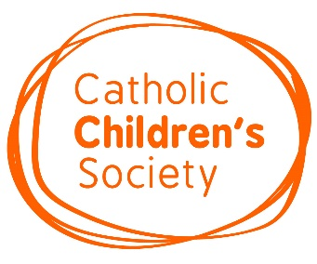
Catholic Children’s Society (CCS) Lent 2022

CCS Lent Appeal: One Community

This year’s CCS Lent Appeal is inspired by Pope Francis’s call to support everyone’s mental health by building a ‘culture of community’.
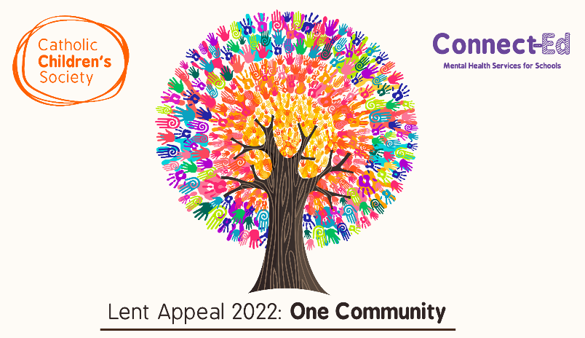
CCS counsellors and therapists have developed resources and activities to help promote positive mental health and emotional wellbeing in schools.

Resources are based on the 5 Ways to Wellbeing. The resources explore each of the 5 themes and provide engaging activities for pupils to complete in school and at home.

Differentiated PowerPoint presentations, introductory videos, notes for teachers and activity sheets are available here:
CCS Lent Appeal: One Community

Pupils can also learn about how they can help vulnerable families in their community by supporting CCS:
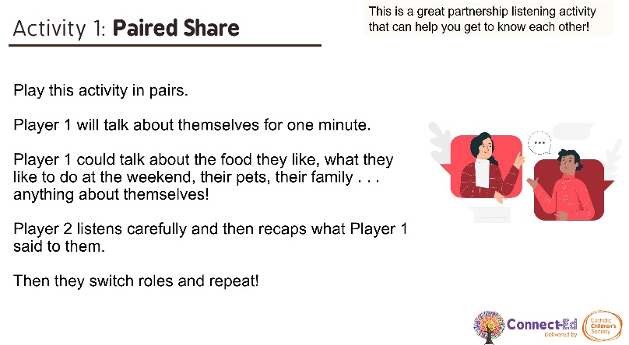
One Community Lent Trail: Pupils can reflect on how they are helping others during Lent.

Fundraising Challenges: Fundraising ideas for your school, including the Walk the Diocese Challenge.

Online Lent Assembly: Find out more about CCS and the difference schools are making to the lives of local children and families.
