Prayer for the 2020 World Day of the Poor

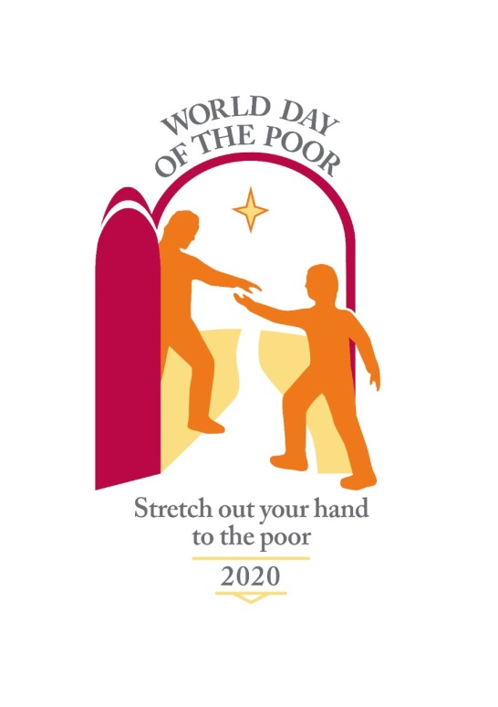
Almighty, ever-living God,
your beloved Son came to us in poverty to win for us the riches of eternal life.
During His time on earth He taught us by word and deed.
From His death we learned of the immensity of His love;
from His resurrection we learned how to believe and to trust
that our lives have purpose from beginning to end.
Help us never to forget that every person has value and is loved by You.
Remind us that, as Your people grow older,
they do not cease to be people worthy of respect, understanding and appreciation.
Though the eyes of the elderly may grow dim,
we pray that their vision of everlasting life with You may grow ever stronger;
though their bodies may become frail,
we pray that their faith may empower them;
though their minds may falter,
we pray that their memories may bring them comfort and peace.

Lord God, may we never forget your Golden Rule
to treat others as we would wish to be treated
and remember to apply that Rule most especially
during the golden years of age.
Save us from falling into the trap of seeing the elderly as a burden.

We ask you, Lord God, to help us set aside material wealth
so as to recognise the spiritual riches of patience, compassion and love for all your people.
As we journey through this life side by side,
may we learn to support one another with the combined wealth of
youth, strength, wisdom and experience
until we are called to the place you have prepared
for all those who are poor in spirit and rich in love.
We make our prayer through our Lord Jesus Christ your Son,
who lives with You and the Holy Spirit, one God, for ever and ever.
Amen.

We are grateful to a volunteer and the Little Sisters of the Poor for this prayer.

