St Mary’s Catholic Primary School
Spring Newsletter
Year 2
Dear Parents,

Welcome back to the Spring term. We hope you all had a lovely Christmas and New Year! We would like to say a huge thank you for the generous cards and gifts received before Christmas.
Homework
Homework will continue to be given out on Thursdays and will need to be returned to school for marking on Monday. Children will be tested weekly on their spellings and therefore it would be helpful if you could help your child to practise reading and writing the words they are given each week. All children are also asked to continue to practise their two, five- and ten-times tables as this term these will also be tested weekly.
Reading
Please ensure that your child brings their reading book into class every day and please read regularly with your child at home. Remember to ask your child questions about the text they read as this will help them to improve their comprehension skills. Please note that reading records must be signed by an adult each time a child has read, this may only be a page from a book but must still be recorded in the child’s reading record book. Children are given a reading book on Mondays and some children will still receive a Monster Phonics book on a Friday. All books must be returned on Mondays.
P.E.
P.E. will continue to be on Monday and Tuesday. Please ensure that your child has the correct kit and that everything is labelled with your child’s name. The correct kit is a school jumper, white t-shirt and blue jogging bottoms. Earrings should be removed on these days. We also ask that you check that PE shoes still fit. School shoes must be worn coming to school and children will change into PE shoes before a PE lesson.

Reminder:
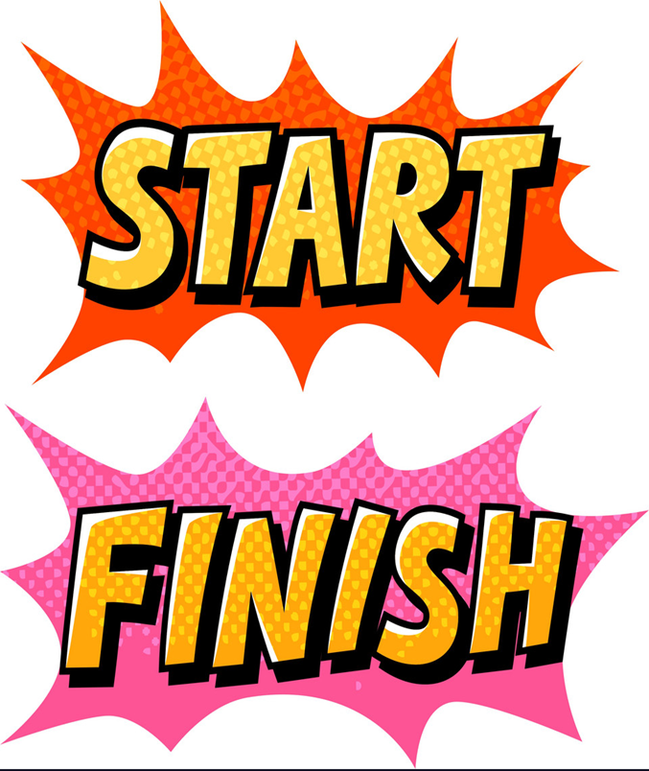
The school day begins at 9:00, this is when the class register will be taken. As you know, gates are opened before this, usually around 8:45.
It is extremely important your child is on time as much as possible. This allows them to set up and feel ready for the day.
The school day ends for KS1 children at 3:00. We would appreciate children being collected on time as KS2 begin their dismissal at 3:15 and the playground can become quite crowded.
The gate is locked around 3:25, after this time you will need to collect your child from the Main Office and sign them out.

If at any time you have any queries about your child or their work then please do not hesitate to contact us.
Thank you for your continued support and we look forward to working with you and your child over the coming term.

Kind regards,

Ms Soto

Numeracy
In Numeracy we will be focusing on multiplication, division, fractions and time. Place value, addition and subtraction will be revisited where possible through extra challenges or starters.

Literacy
In Literacy we will be reading ‘The Colour Monster’, ‘Paddington’ and ‘Lila and the Secret of Rain’. We will complete work related to each of these stories. We will also look at Newspaper Report writing, linked to our History topic, The Great Fire of London. There will be a continued focus on grammar, handwriting and reading comprehension throughout the term.

Science
This term we will be learning about ‘Animals including Humans’ and ‘Plants’.

R.E.
Galilee to Jerusalem
In this branch, pupils will experience the ministry of Jesus, the Word of God. They will learn about the life of Jesus and his revelation of the Kingdom of God through parables, encounters, miracles, and teachings.

Desert to Garden
At the end of Branch 3 we left Jesus about to enter Jerusalem, on what we would call Palm Sunday. Desert to garden walks us through Jesus' last week, using the metaphor of gardening to image what happens.
We continue to read Luke's Gospel as our base text.

D&T
We will be looking at building stable structures.

ICT
This term In ICT we will be looking at ‘online safety’ and data handling. Children will learn how to keep safe online and to understand why sharing personal information is dangerous.

History:
In History we will be learning about the Great Fire of London. The children will be ordering the events, answering questions and writing all about the historical events of London.

Geography
We will be learning about different climates of the world, locating them on a map and comparing and contrasting them to one another.

Art:
This term we will be focusing on George Seurat. We will learn about the artist himself and try and recreate some of his artwork.

PSHE
Module 2: Created to Love Others
Created to Love Others explores the individual’s relationship with others. Building on the understanding that we have been created out of love and for love, this module explores how we take this calling into our family, friendships and relationships, and teaches strategies for developing healthy relationships and keeping safe.

P.E.
2 sessions weekly, taught by a specialist coach from Non-Stop Action

